# Exercise -4

Financial Forecasting:

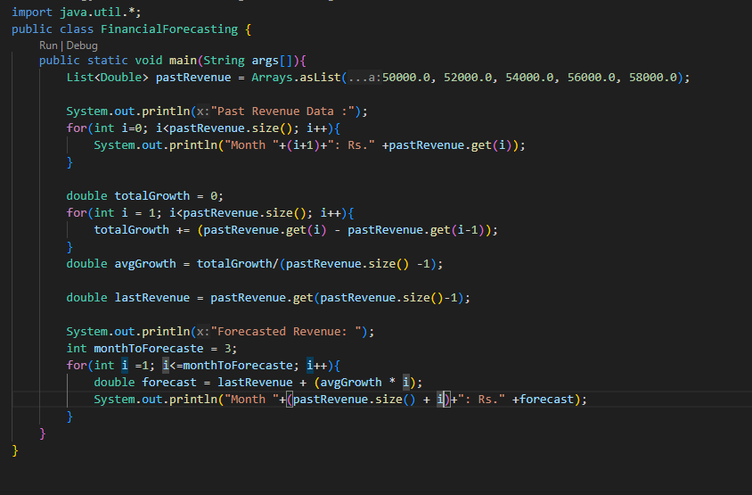

Output:

